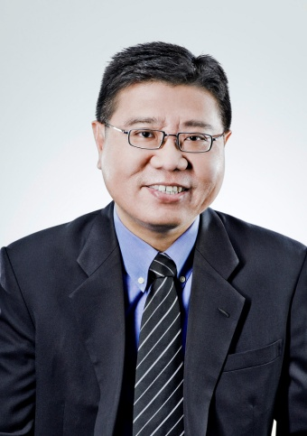

Toh Kian Sing SC

Profession: Advocate & Solicitor

Toh Kian Sing is a Senior Partner and Head of the Shipping and International Trade Practice Group of Rajah & Tann Singapore LLP. He obtained his law degrees from the National University of Singapore and the University of Oxford and was appointed Senior Counsel in 2007.

Kian Sing has nearly two decades’ experience handling trade finance matters, both of a contentious and non-contentious nature. He acted as counsel in many of the reported Singapore decisions involving letters of credit as well as advised Singapore banks and commodity houses in trade finance litigation in jurisdictions such as the UK, New York, Korea, China, India and even Iraq. He also handles drafting and non-contentious work for banks and is responsible for preparing the complete set of letter of credit forms for several leading trade finance banks in Singapore. He has written on the subject of letters of credit and warehouse financing and regularly lectures on these areas.

He has also acted as counsel in numerous commodity cases and has in the process developed in depth industry knowledge in oil, coal and iron ore trading. Kian Sing also regularly accepts appointment as arbitrator in charterparty, shipbuilding, commodity and joint venture disputes. Proficient in Chinese, he is also a Visiting professor at the Dalian Maritime University, having previously lectured at the Law Faculty of the National University of Singapore.

Sits as sole arbitrator and as part of a tribunal in commodity, charterparty, bunkers and joint venture disputes in institutional (SIAC, SCMA, ICC and LMAA) and ad-hoc arbitrations conducted in Singapore and elsewhere. He is able to conduct arbitration in Chinese.

Member of Regional Panel of Singapore International Arbitration Centre since 2003, Singapore Chamber of Maritime Arbitration since 2005, China Maritime Arbitration Commission since 2005.

Acts as lead counsel in charterparty, ship-building, ship repair, bunkers, commodity and joint venture arbitrations in Singapore, Hong Kong and London. Also involved in arbitration hearings conducted in Shanghai and Oslo.

An accomplished legal writer, he authored the only book (now into the second edition) on Admiralty Law and Practice in Singapore which is relied on by both practitioners and academics alike locally and in other jurisdictions. He has also contributed chapters to various books and published articles on respected international legal publications.